Place Order as Parent

Document Information

|  |  |
| --- | --- |
| **Document Title** | Title of use case – Verb Noun phrasing is almost always the most appropriate! |
| **Document Owner** |  |
| **Version** |  |
| **Status** |  |
| **Date** |  |

1. Brief Description

This use case allows the parent to place an order for lunch on a specific day for a student whose accounts were linked to each other.

1. Actors

* Parent

1. Trigger

The parent decides to place an order for lunch on a specific day for a student whose accounts were linked to each other.

1. Pre-Conditions

* The parent must be logged in to the system.
* The student has sufficient balance in their account to pay for the selected food items.
* The selected day is not the day in the past.
* The parent and student’s accounts must be linked to each other.

1. Post-Conditions

* The student’s account balance is reduced by the amount of the order.
* The order is added to the list of orders for the selected day of the student and the school administrator.
* An order code is generated and displayed to the student for later use.

1. Basic Flow
2. The parent logs in to their account on the School Lunch Ordering System.
3. The parent select the student account.
4. The parent selects the day they want to order for.
5. The parent selects the food items and quantity.
6. The parent confirms the order by selecting “Confirm” button.
7. The parent deducts the amount from the student’s account balance.
8. The system generates the order detail including an order code, order time, food item,… at the “My Order” menu.
9. The system returns the parent to “My Order” page.
10. Alternate Flows
11. Exception Flows

* 5a. If the student does not have sufficient balance in their account, the system will prompt an error message to tell the parent to top up the student’s account before proceeding with the order. The system then returns to step 4.

1. Business Rules

* The parent can only order for the student’s account which was linked to their account.
* The parent can only order up to the maximum quantity allowed for each food item.
* The parent can only order up to the balance amount in the student’s account.

1. Non-Functional Requirements

* The system should process the order quickly to prevent delays for other users (1s).
* The system should provide clear and concise messaging to the parent throughout the ordering process.

1. Supplemental Requirements
2. Visual Model

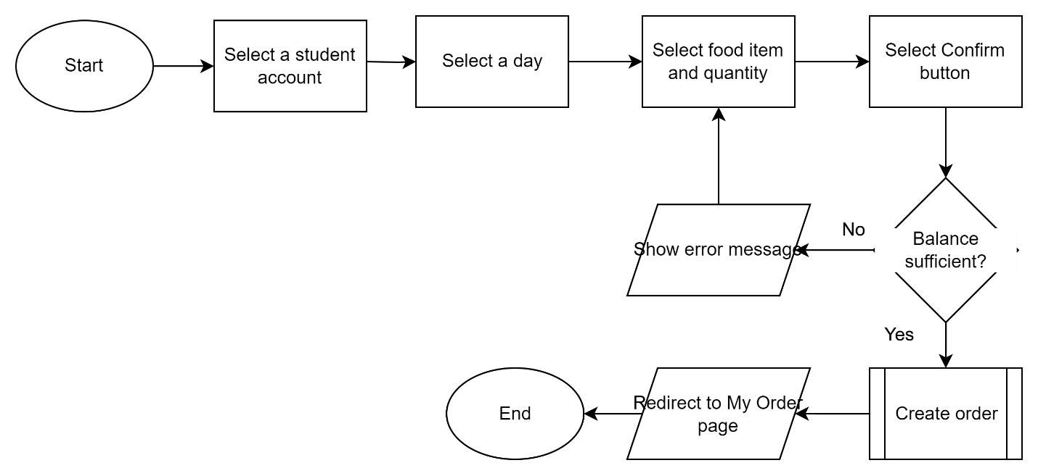

Revision History

|  |  |  |  |  |
| --- | --- | --- | --- | --- |
| V. | Date | Author | Description | Status |
|  |  |  |  |  |
|  |  |  |  |  |